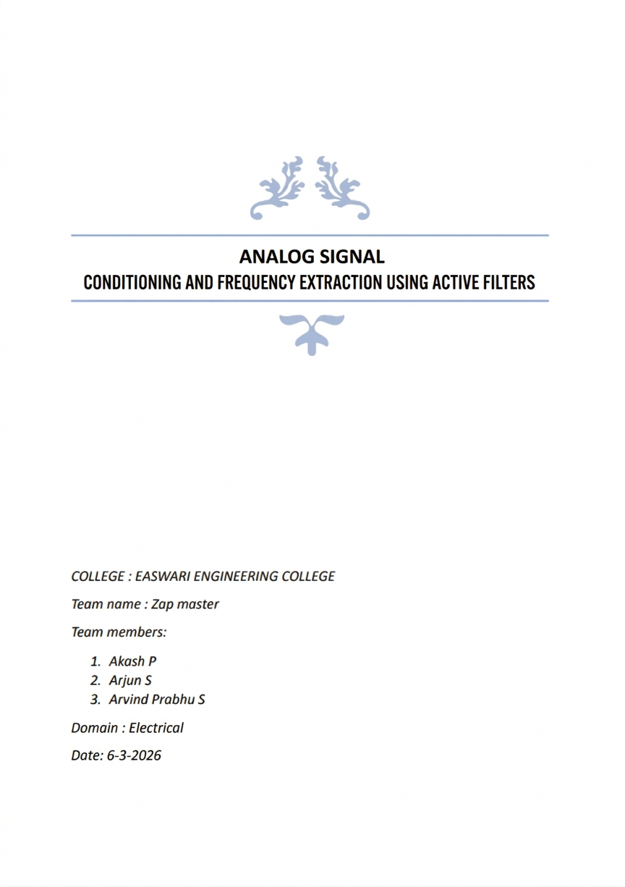

Objective
The objective of this project is to design an analog signal conditioning circuit capable of extracting a usable signal from a composite input signal generated by a black-box sensor module. The composite signal contains multiple deterministic interference components and broadband noise. The goal is to suppress these unwanted components and ensure that the 6 kHz usable signal dominates the output.

System Design
The system processes the composite sensor signal using a multi-stage analog signal conditioning architecture. The composite signal includes the following components:
Component A – 600 Hz : Low frequency drift
Component B – 6 kHz : Usable information signal
Component C – 18 kHz : Structured interference
Component D – 55 kHz : High frequency interference
Component E – Broadband noise

Signal Conditioning Stages
1. Input Buffer Stage
The circuit begins with an operational amplifier configured as a voltage follower buffer. This stage isolates the black-box signal source (50 Ω source impedance) from the filtering stages.
2. High Pass Filtering
A high-pass filter suppresses the 600 Hz low frequency drift while allowing the useful signal at 6 kHz to pass with minimal attenuation.
3. Frequency Shaping Stage
A passive RC network provides frequency dependent shaping that attenuates low frequencies while allowing the region around 6 kHz to pass effectively.
4. Interference Suppression Filters
Cascaded low pass filters suppress high frequency interference components including the 18 kHz structured interference and 55 kHz disturbance.
5. Manual Adaptation Interface
A 100 kΩ potentiometer provides continuous tuning of the circuit response. A 1 kΩ series resistor ensures stable operation.

Calibration
Calibration is performed by observing the output FFT spectrum while adjusting the potentiometer. The optimal calibration occurs near Rknob ≈ 90 kΩ where the 6 kHz component dominates the spectrum.
Circuit Diagram
1) With Maximum Gain (Rknot=90K)
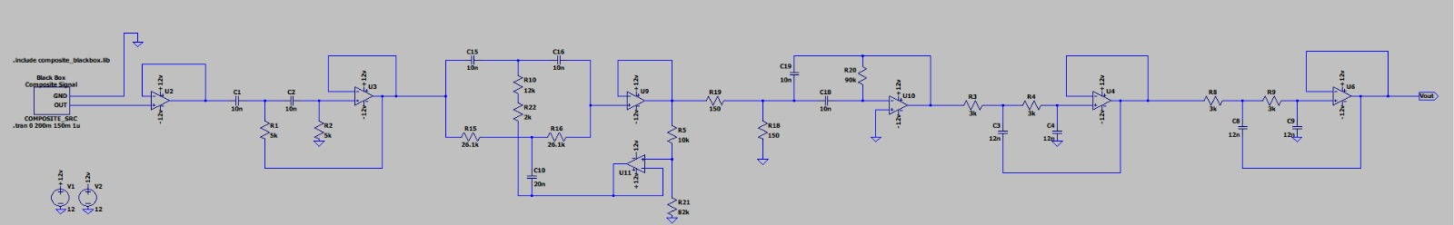

2)With Potentiometer
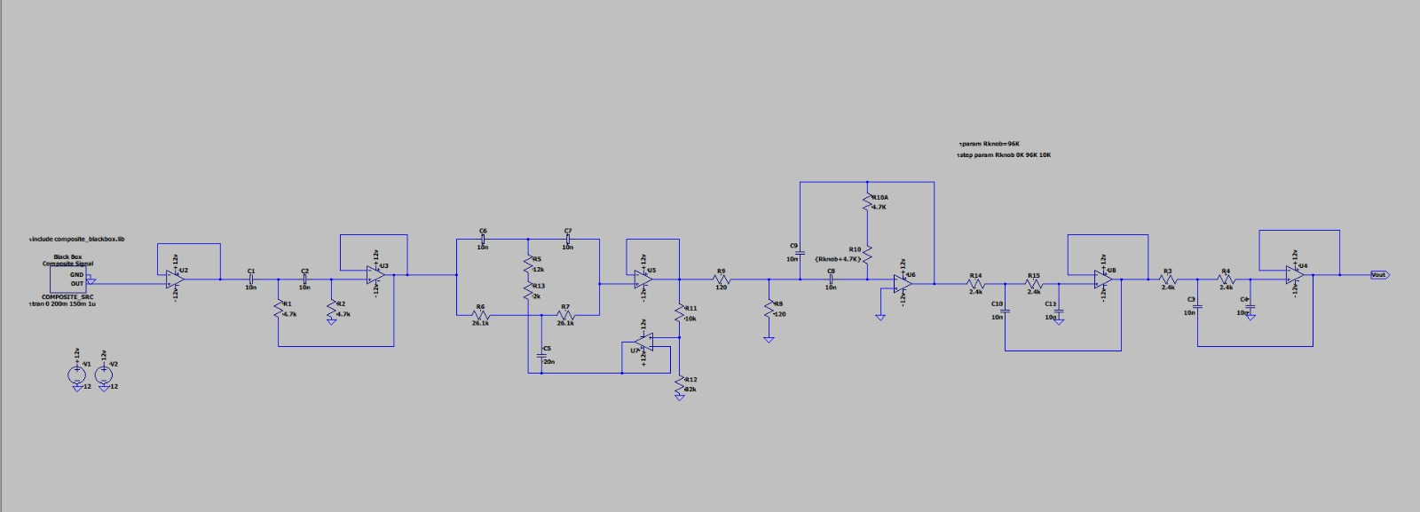

Simulated Output
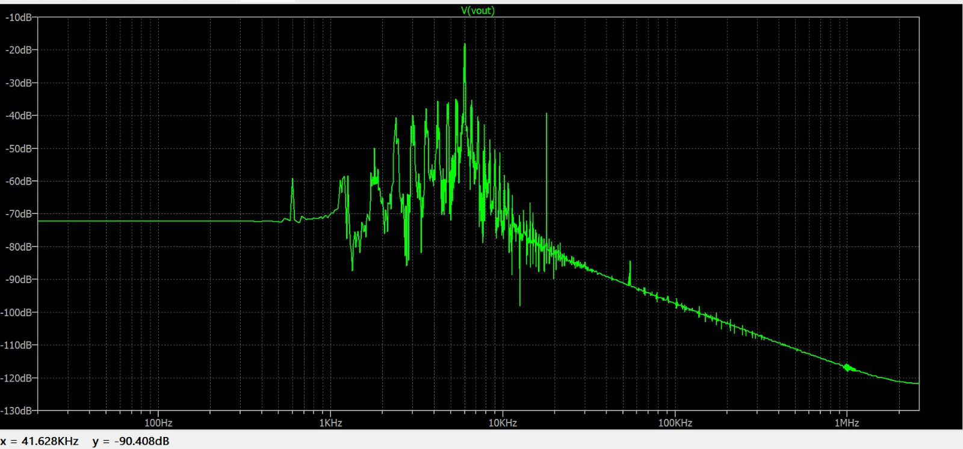

Measured Output Spectrum:
Frequency | Signal Type | Output Magnitude | Relative to 6k
600 Hz | Drift | -59.5dB | -41.5dBc
6 kHz | Usable Signal | -18dB | 0 dBc
18 kHz | Structured interference | -39.2dB | -21.2 dBc
55 kHz | HF interference | -84.4dB | -66.4 dBc

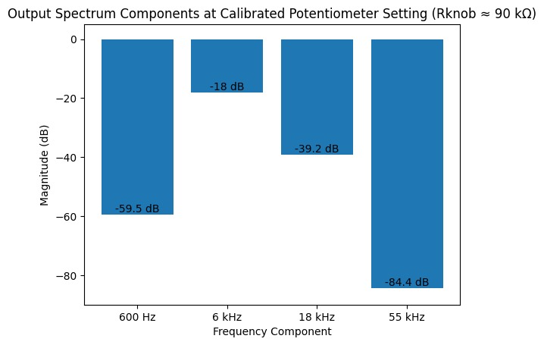With Potentiometer-
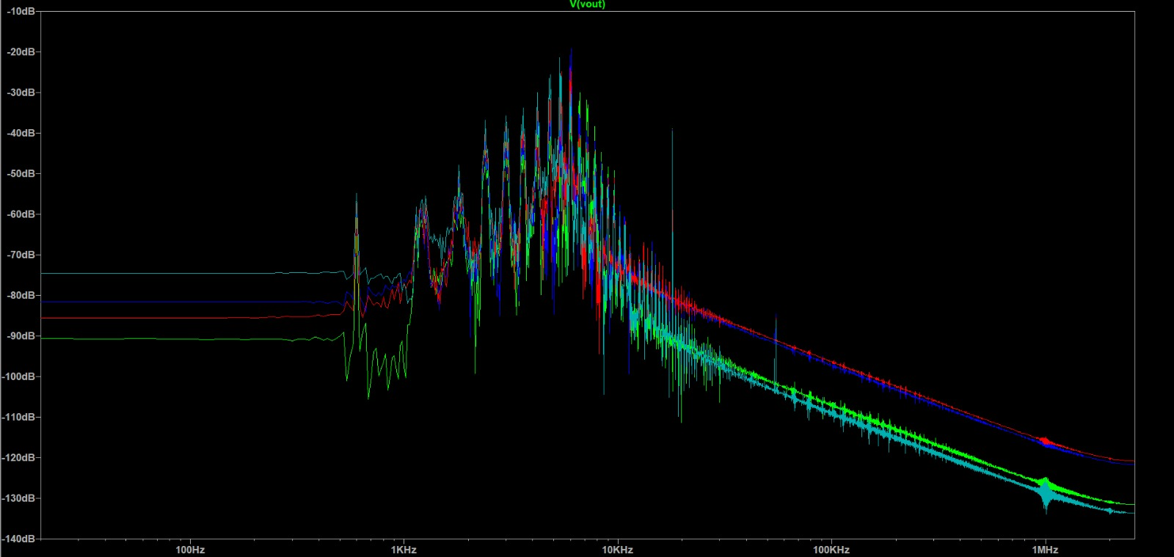

Transient Analysis:
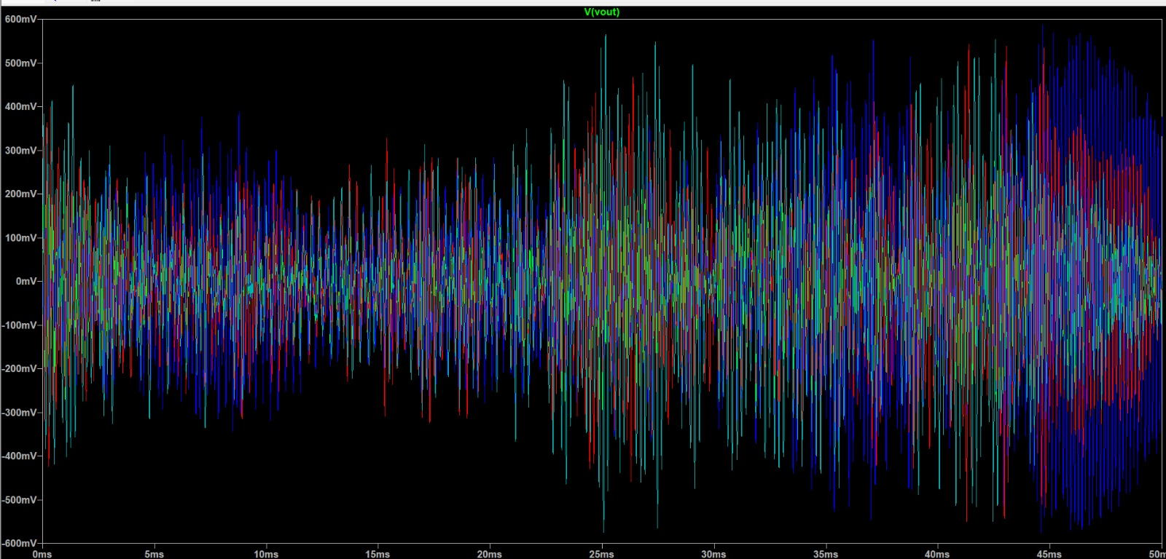

PCB Design
Schematic layout:
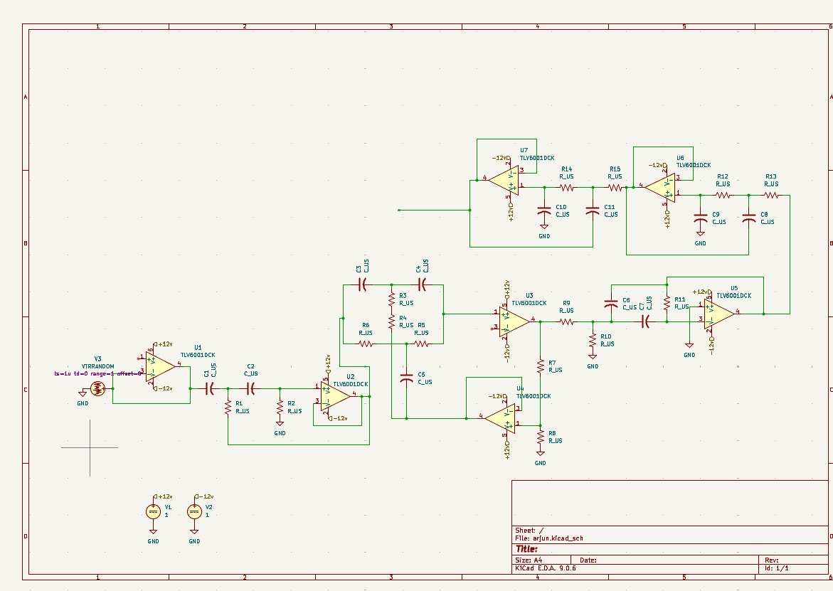

Footprint:
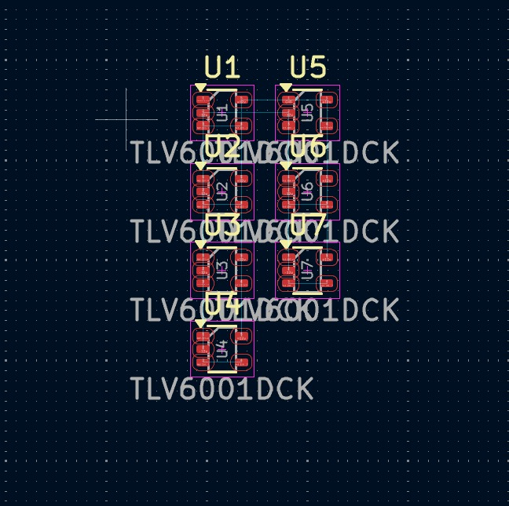
3D view:
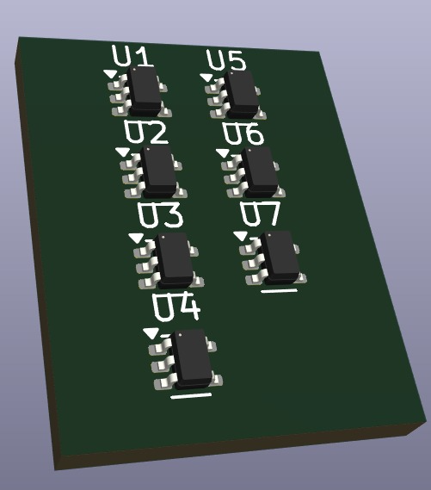

Conclusion
The proposed analog signal conditioning circuit successfully extracts the 6 kHz usable signal from the composite noisy input. The design suppresses interference components while maintaining stable and repeatable operation.

